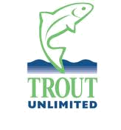

The Forks of the Delaware, Hokendauqua, Little Lehigh,
& Monocacy Chapters of Trout Unlimited
16th Annual Spring Event

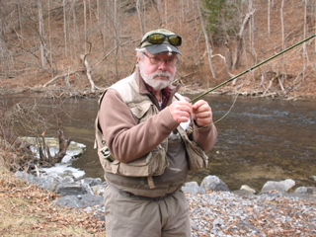
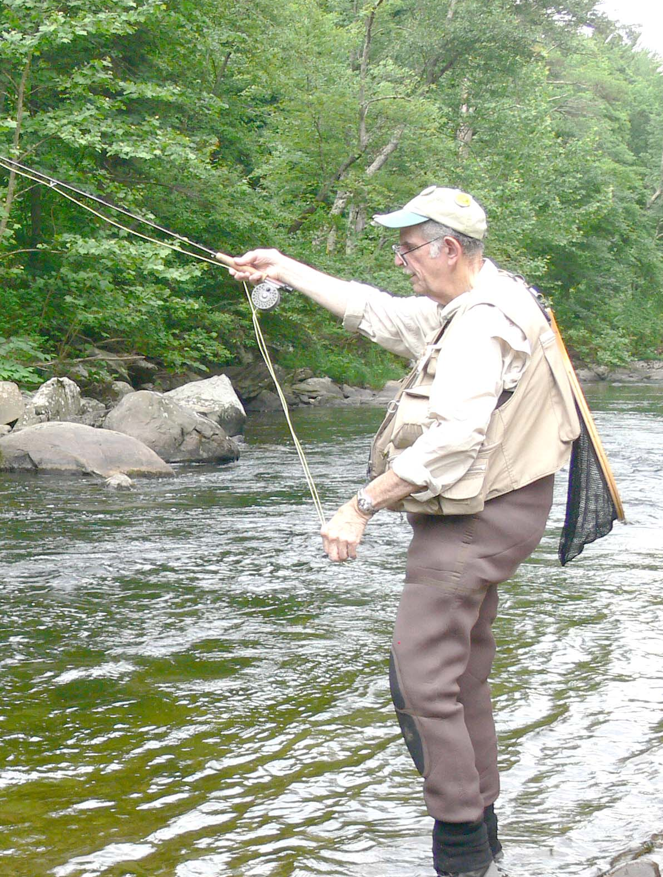

FEATURED SPEAKER
DAVE ROTHROCK
Presenting: “FLY FISHING NORTH CENTRAL PENNSYLVANIA”
When you combine great scenery often referred to as “God’s Country”, great streams, great hatches and great trout – well, it doesn't get much better than this!
Dave Rothrock has been pursuing trout, and other species, with a fly rod since the mid-1960's and he's been tying flies for a bit longer than he's been fishing them. He has fished throughout the East, into the Midwest, and Europe.

Dave's articles have appeared in FLY FISHERMAN, AMERICAN ANGLER and PENNSYLVANIA ANGLER magazines as well as other publications. His fly patterns have graced the pages of various publications, books and calendars. He has presented programs on fly-fishing related topics to groups throughout the Eastern U.S. and Canada. Dave is also a co-author of the book “Keystone Fly Fishing: The Ultimate Guide to Pennsylvania's Best Water.”

Dave has worked as an instructor in the L. L. Bean fly fishing schools and has taught fly fishing, casting and fly-tying classes for various fly shops, utilizing many of the best trout streams in central and north central Pennsylvania as his classroom environment.
Dave currently guides and teaches fly fishing and casting through his business, Salmo-Trutta Enterprises.
March 10, 2018, 9:00 a.m. – Noon
East Bath Rod & Gun Club, 7905 Township Line Rd, Bath, PA
Free Admission Continental Breakfast
RAFFLES! RAFFLES! RAFFLES!

